P

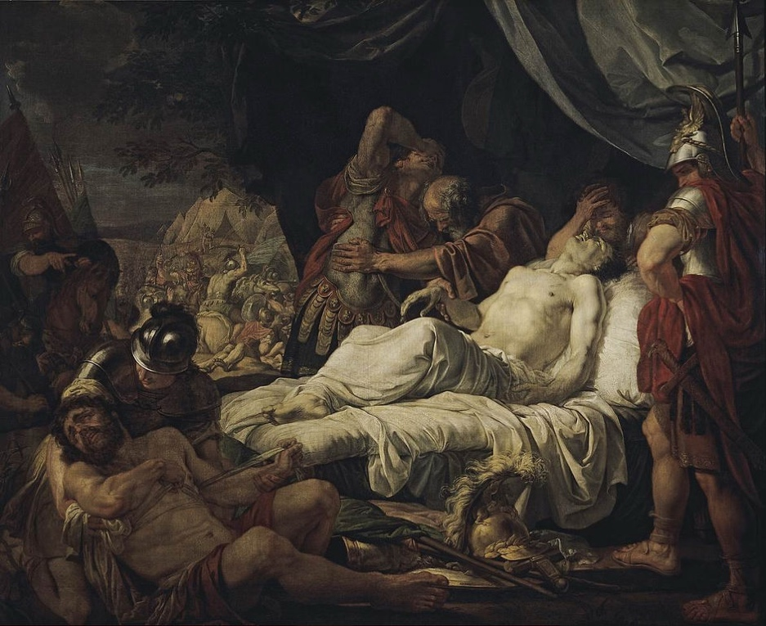reface

Those who first assumed that the arts are like the bodily senses, seem to me to have perceived very clearly the power of making distinctions, by which we are enabled to apprehend opposites.

Sense and perception

Our sense-perception has no greater facility in distinguishing white objects than black, or sweet things than bitter, or soft and yielding substances than hard and resisting ones, but its function is to receive impressions from all objects alike, and having received them, to report the resulting sensation to the understanding.

Figure (Death of Pelopidas, by Andrey Ivanov)

(Plutarch, 1st centure AD)

A

rts

The arts, on the other hand, proceed by the use of reason to select and adopt what is appropriate, and to avoid and reject what is alien to themselves. They contemplate one class of objects by preference and with direct intent, yet incidentally contemplate the other class also in order to avoid it.

Healing and Harmony

For instance, the art of healing has incidentally studied the nature of disease, and the art of harmony the nature of discord, so that they may produce their opposites. And the most consummate arts of all, namely: temperance, justice and wisdom, since their function is to distinguish, study not only what is good and just and expedient, but also what is bad and unjust and disgraceful.

Flute players

One Ismenias used to exhibit both good and bad flute-players to his pupils, and say: "you must play like this one", or again, "you must not play like this one"; and Antigenidas used to think that young men would listen with more pleasure to good flute-players if they were given an experience of bad ones also.

Epilogue

Therefore, alike, we shall be more eager to observe and imitate better men if we are also exposed to the narratives of bad and blameworthy.

Table of Contents

Preface 1

Sense and perception 1

Arts 2

Healing and Harmony 2

Flute players 2

Epilogue 2

Table of Figures

Figure 1 (Death of Pelopidas, by Andrey Ivanov) 1

# Bibliography

Plutarch. (1st centure AD). *Parallel Lives: Life of Demetrius.* Chaeronea.